**Part A**

**What will the following commands do?**

**1.echo "Hello, World!"**

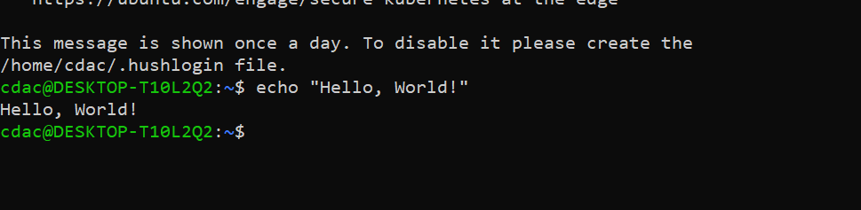

**2.name="Productive"**

**3.touch file.txt**

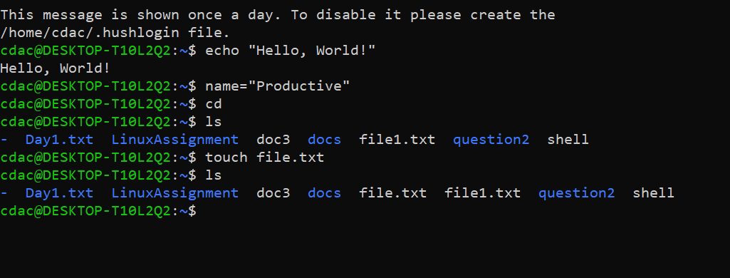

**4.ls -a**



**5.rm file.txt**

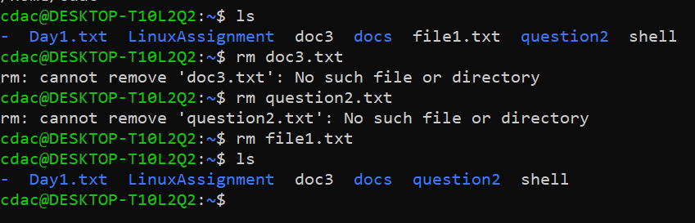

**6.cp file1.txt file2.txt**

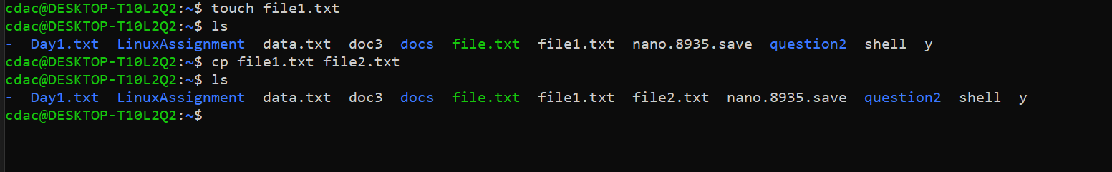

**7. mv file.txt /path/to/directory/**

**8.chmod 755 script.sh**

**9.grep "pattern" file.txt**

**10. kill PID**

**11.mkdir mydir && cd mydir && touch file.txt && echo "Hello, World!" > file.txt && cat file.txt**

**12. ls -l | grep ".txt"**

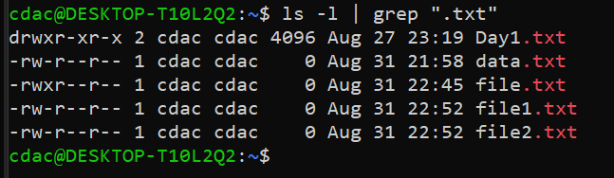

**13. cat file1.txt file2.txt | sort | uniq**

**14. ls -l | grep "^d"**

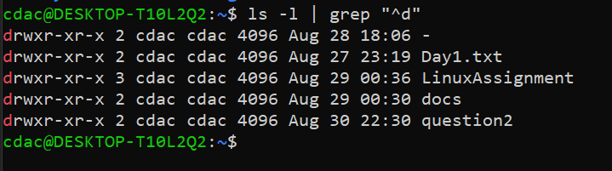

**20.chmod u+x file.txt**

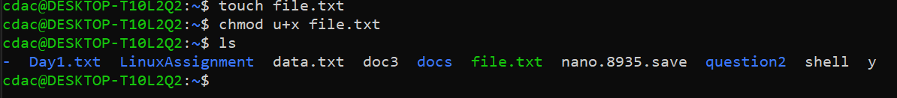

**21. echo $PATH**

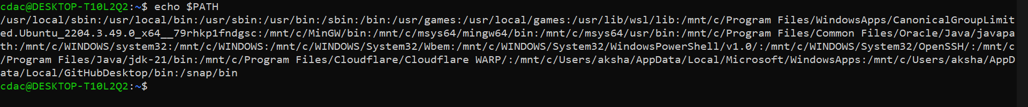

**Part B**

**Identify True or False:**

**1. ls is used to list files and directories in a directory.-True**

**2. mv is used to move files and directories.-True**

**3. cd is used to copy files and directories.-True**

**4. pwd stands for "print working directory" and displays the current directory.-True**

**5. grep is used to search for patterns in files.-True**

**6. chmod 755 file.txt -gives read, write, and execute permissions to the owner, and read and execute permissions to group and others.-True**

**The command chmod 755 file.txt sets the following permissions:**

* **Owner: Read (4), Write (2), Execute (1) = 7 (read, write, and execute)**
* **Group: Read (4), Execute (1) = 5 (read and execute)**
* **Others: Read (4), Execute (1) = 5 (read and execute)**

**7. mkdir -p directory1/directory2 creates nested directories, creating directory2 inside directory1**

**if directory1 does not exist.-True**

**8. rm -rf file.txt deletes a file forcefully without confirmation.-True**

**The command rm -rf file.txt deletes the file file.txt forcefully without asking for confirmation.**

**Identify the Incorrect Commands:**

**1. chmodx is used to change file permissions.**

**Corrected command- chmod: Used to change the permissions of a file or directory.**

**2. cpy is used to copy files and directories.**

**Corrected command cp: Used to copy files and directories.**

**3. mkfile is used to create a new file.**

**Corrected command- touch command is used to create a new file**

**4. catx is used to concatenate files.**

**Corrected command -cat: Used to concatenate and display the contents of files.**

**5. rn is used to rename files.**

**Corrected command -mv: Used to move or rename files and directories.**

**Part C**

**Question 1: Write a shell script that prints "Hello, World!" to the terminal.**

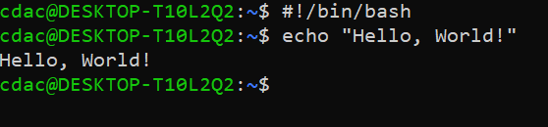

**Question 2: Declare a variable named "name" and assign the value "CDAC Mumbai" to it. Print the**

**value of the variable.**

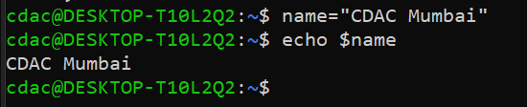

**Question 3: Write a shell script that takes a number as input from the user and prints it.**

**Question 4: Write a shell script that performs addition of two numbers (e.g., 5 and 3) and prints the result.**

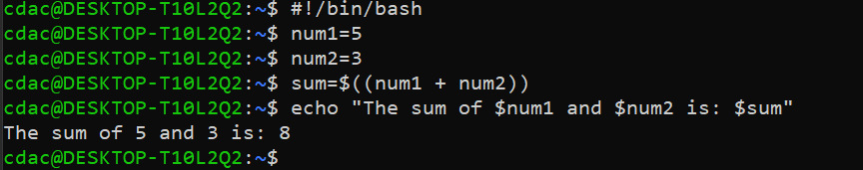

**Question 5: Write a shell script that takes a number as input and prints "Even" if it is even, otherwise prints "Odd".**

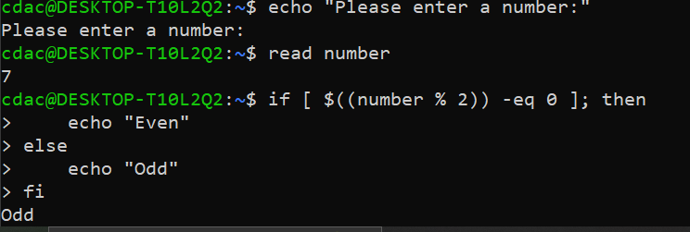

**Question 6: Write a shell script that uses a for loop to print numbers from 1 to 5.**

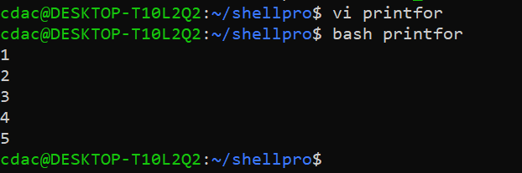

**Vi printfor command**

**#!/bin/bash**

**for ((i=1; i<=10; i++))**

**do**

**echo "$i"**

**done**

